Open Water
Safety Policy

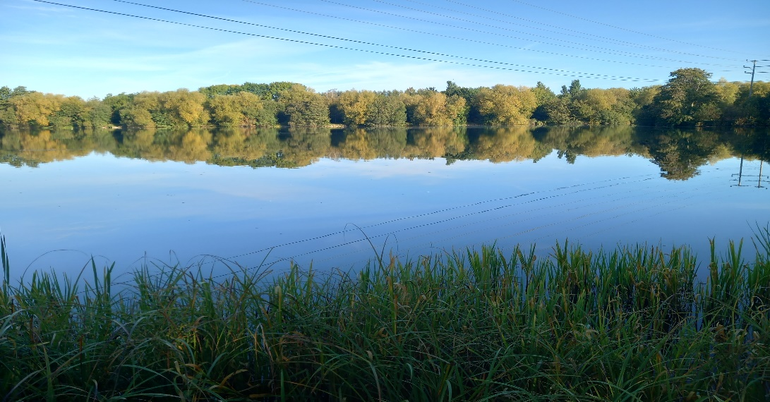
Witney Town Council

Reviewed 2022
Revised/Agreed/Adopted 20??

Water Safety Policy Open Water Sites

Foreword

Sharon Groth Town Clerk

Section

Foreword
- Statement of Intent
- Safety Criteria for Management and Design
- Environmental Management
- Risk Assessment
- Safety Inspections Hazard Identification
- Supervision of Open Water Sites
- Rivers and Brook Courses
- Rescue Equipment
- Provision of Information
- Reporting of Accidents and Incidents
- First Aid Provision at Open Water Sites
- Ice on Open Water
- Use of Open Water for Activities

Appendices

- Open Water Rescue Provision
- Site Operation Procedure
- Emergency Accident/Incident Reporting Procedure

FOREWORD

Sharon Groth
Town Clerk
Witney Town Council

Within parks and public open spaces of Witney there are a range of open water features which enhance the environment for the enjoyment of people of all ages. These include lakes, rivers, SUDs through to tributaries which flow from small streams into fast flowing rivers like the river Windrush

These natural features however present a significant risk to persons in summer when it is hot and swimming in cold water is attractive; and in winter when children and young people are attracted to and may put themselves at risk by walking on ice over deep water.
WTC in its risk assessment process will do all that is reasonably practicable to protect people from danger, this policy has been established and with this objective in mind. We will continue to bid for resources into the maintenance and management of open water. However, budgets are limited, and as major schemes are implemented through the Town Councils Capital Program???????? or other capital funding that is subject to a bidding process.

If you have any suggestions to improve water safety at one of our sites, please let us know. Please write to me at the address below or telephone
Sharon Groth
Town Clerk & Chief Executive
Witney Town Council
Town Hall
Market Square
Witney
Oxfordshire
OX28 6AG
Date: October 2022

Water Safety Policy

Statement of Intent
The Town Clerk will provide appropriate management arrangements and take measures to ensure that, so far as is reasonably practicable, all open water facilities and other areas of open water such as culverts, rivers, and streams, are maintained in a safe condition for the benefit of users.
WTC does not support or approve the use of any area of open water for swimming or other in/on water recreational activity

Safety Criteria for Management and Design
There is continuous work being carried out to open water areas within or ownership, for example de-silting, water edge treatment etc. Before such work is undertaken several design factors will be taken into consideration to further improve safety.

Edge gradients
The critical feature of all water edges is the gradient above and more importantly, the gradient below the water line. How the edge is then treated will be influenced by environmental factors. Where the water edge is open and accessible and is to remain so, the edge profile should be graded appropriately.

It is recommended that shallow water (less than 0.66m) should be extended a minimum of 2m from the water edge, via 1:3 gradients, and a further protective margin of 1.75m with depths from 0.65 to 1.36m via a 1:2.5 gradient.

Planting
Alternatively, where access to the water’s edge is not required, but either a steep gradient
(Falling risk) or very shallow gradient (swimming temptation) exists, planting of vegetation
and natural vegetation will provide adequate and aesthetic protection.

Steep gradients
Where a steep gradient slopes down into open water, dense vegetation should be allowed to grow naturally or planted to prevent visitors reaching the water.

Shallow gradients
Where the edge is not steep, the risk of falling into the water is reduced. However, to deter swimmers, planting of water plants (reeds, willow etc) may assist in discouraging persons entering the water at these points.

Environmental Management
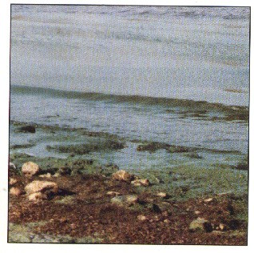
Where wildlife may be put at risk because of pollution (oil/blue green algae/etc) or pollution found to be present in or entering open water, Town Council Staff must report such occurrences immediately to their line manager who in turn, will notify the Park Ranger or Representative and Safety Section for the appropriate action to be taken.

It is often the case that the Environment Agency will report the presence of blue green algae to us. In such cases, we will ensure that appropriate warning notices are displayed around the affected area and that water-based recreation is prohibited or restricted until the water condition improves

FISH DEATHS AND ENVIRONMENTAL INCIDENTS
Where incidences of large-scale fish deaths or other wildlife are identified or reported (Please see local NOP/EAP for further details.)
Risk Assessment
Managers responsible for open water sites are responsible for carrying out Risk Assessment. The results of these risk assessments including any action taken to reduce or eliminate hazards will be formally recorded in compliance with the Risk Assessment Policy. Where a risk assessment has previously identified areas known to be attractive for swimming, additional "signs, normally positioned at main entrances to the site in addition to those displayed within life buoy stands, will be positioned at regular intervals around the water's edge as determined by the risk assessment

As an addition a site-specific Open Water Risk Assessments will be undertaken as part of the site risk assessment process this will identify any specific additional water hazards inclusive of changing water levels. A checklist has been developed to assist risk assessors with this assessment. The assessment will be undertaken as required

Safety Inspections/Hazard Identification
We will ensure that routine safety inspections are undertaken by the Towns staff or by officers of Town Council. Additional inspections will be undertaken as required

Inspection of rescue equipment is carried out on a regular basis

The results of all inspections will be recorded, and records will be maintained by the Operations Manager. At the request of the Town Clerk ad hoc audits on the provision of rescue equipment will be undertaken by The Park Ranger. Safety inspections will monitor:

  - The provision of rescue equipment
  - Safety signs and other information notices
  - Condition of the water and surrounding edges/banks

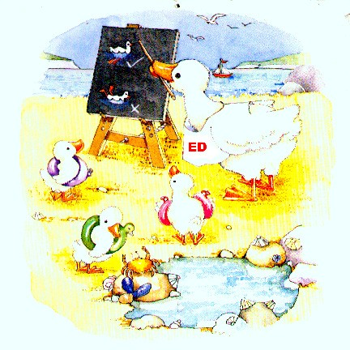
Where a shortfall in the provision of equipment or information is identified, this will be recorded in the inspection report. Where the inspecting officer considers that the shortfall represents a significant hazard, the Town Clerk will be notified

Supervision of Open Water Sites

Full time supervision is deemed to be neither reasonably practicable nor the most
effective response to a water hazard. Where angling is the only approved activity,
supervision is not necessary. During summer months, staff working at larger sites
with areas of open water will have special regard to any open water usage taking
place.

In certain circumstances and when staffing levels and duties permit, the Ranger Service or other members of staff may take a proactive role in preventing access to areas of open water for unauthorized activities such as swimming. In recognizing the importance of this as a means of educating members of the public,

Rivers and Brook Courses
In circumstances where rivers or brook courses run through parks and public open spaces under normal conditions the depth of water is negligible, and only in flood conditions the risk to users of the site increases. It is not practical to sign or provide lifebuoys for all sites where rivers and brook courses flow, in the event of such storm or flood conditions the use of the local media shall be used to highlight the potential increased risk to possible users of these sites.

Rescue Equipment
WTC will make available around all areas of open water, 24" life buoys in solid and highly visible mountings. The locations of the rescue devices will be determined by a risk assessment and will reflect likely points of access to the water and places where a rescue attempt may reasonably take place. However, after taking into consideration locations based on risk assessment, the guide shall be 1 lifebuoy where appropriate, thus allowing reasonable time to locate and use such rescue equipment. Life buoys are often seen by members of the public as a key element in lifesaving. However, they are difficult to use over a distance, rather they invariably serve as a visual reminder of the hazards associated with open water. It is recognised that despite their role in rescue attempts and as a warning reminder, life buoys are also subject to vandalism and misuse.
WTC will ensure that the life buoys and housings are inspected weekly by the Town Council's staff or other nominated person the results of these inspections are recorded. Where vegetation around the lifebuoy stands is identified as an issue on inspections, this will be removed to ensure lifebuoy stands are visible from both sides. Where a shortfall in the rescue provision is identified, WTC will ensure that replacement equipment is made available as soon as possible after the shortfall is discovered.
Where appropriate and because of the risk assessment, additional rescue equipment may be made available either on site or in a vehicle. We will ensure that all staff who may have access to such equipment will receive appropriate training as to its use.

Where persistent vandalism occurs the use of alternative anti vandal lifebuoy stands will be considered. Where persistent problems of vandalism to lifebuoys or where lifebuoys are stolen reasonable action will be taken daily to replace such equipment, allowing for one spare buoy per housing.

Provision of Information
WTC recognises that the provision of appropriate and adequate information on water safety, both to staff and to members of the public, is crucial to the success of the Water Safety Policy and to accident prevention.
Information is made available in several ways.

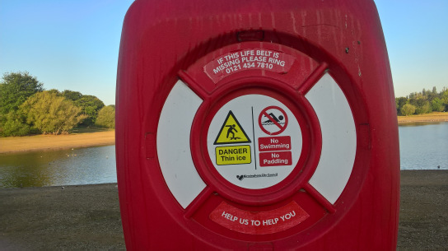
Public Education the Ranger Service can provide information on all aspects of water safety through an outreach program to local schools and community groups, by direct contact with visitors and through regular contact with the various user groups
undertaking various activities at WTC open water facilities.

Providing Literature At larger facilities where a range of users exist, literature highlighting key water safety issues and hazards will be made available to visitors to the facility.

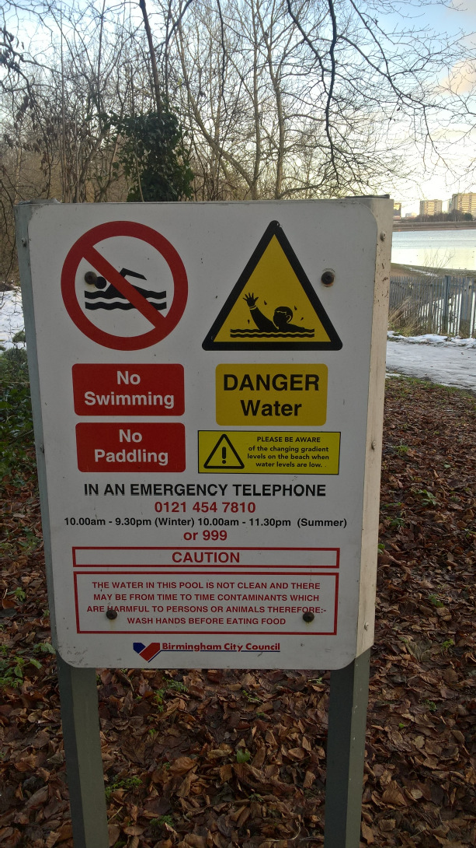
Site Information. Information is provided at principal points of access to facilities with areas of open water that gives details of the layout of the facility, provides a map (at larger facilities), displays principal warning sings in accordance with the recommendations of the RoSPA National Water Safety Committee and the requirements of the Health and Safety (Safety Signs and Signals) Regulations inclusive of emergency telephone facilities or telephone numbers.

Warning Signs
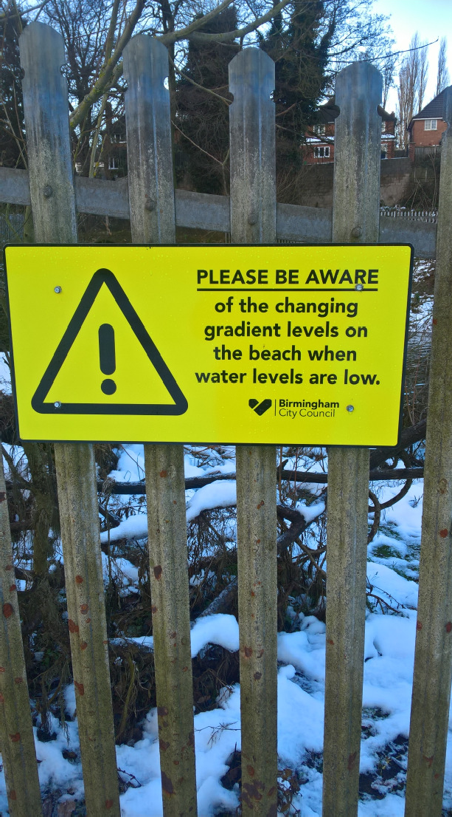
Warning signs in are in place at all main entrances, plus in specific locations further entrance warnings signs may be installed where a particular issue has been identified. All signs are in accordance with the
recommendations of the RoSPA National Water Safety Committee are displayed in areas where there is a particular hazard. In addition, on sites supplementary signage may be installed power lines are present. Additional further nagging signs/stickers are displayed in the centre of life buoy stands repeating entrance sign warning information.

Reporting Accidents and Incidents
Where a member of staff is involved in an incident or sustains injury as a result of an accident, the reporting of the accident/incident must be in accordance with WTC written procedures, a summary of which is included in Appendix 3.

Where a member of the public is involved in an incident or sustains injury through an accident and the accident/incident is witnessed either by a member of the public or the Town Council’s staff, the accident/incident must be in accordance with the procedures in Appendix 3. Members of the public will be encouraged to report accidents/incidents to the Parks Ranger by use of the telephone number displayed on information boards at site access points.

First Aid Provision at Open Water Sites
Except where there is a permanent staff presence on a site where there are areas of open water and at which first aid provision will be determined by a risk assessment, no first aid provision is made.

First aid equipment, in accordance with the standards set out in the current First Aid at Work Approved Code of Practice, is carried on all Local Services vehicles.

Ice on Open Water
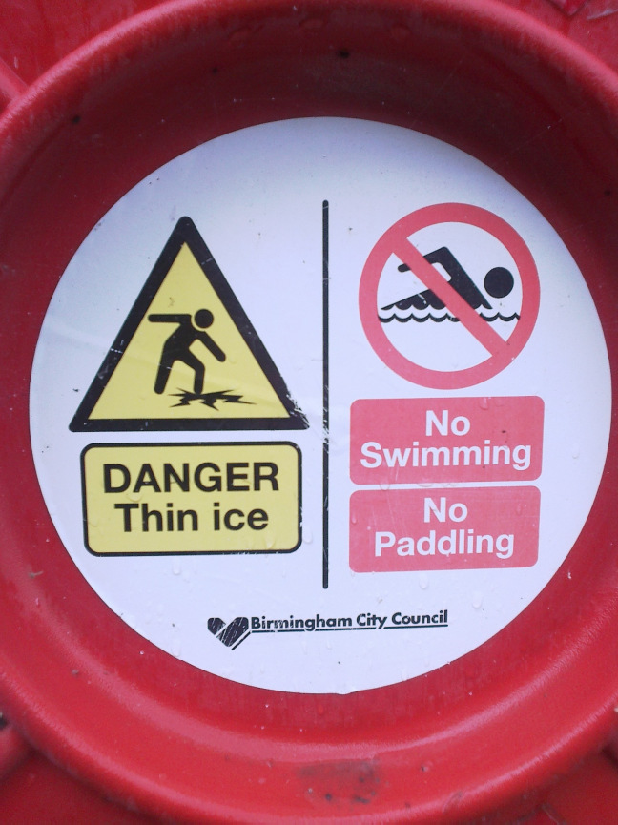
When ice develops on open water at its sites, Witney Town Council will ensure that appropriate and adequate warning signs as shown are displayed at all access points and near to the water's edge. The location of such signs will be to ensure that they give a clear warning of danger to visitors to the site.
The service provider or other nominated officer will be responsible for the replacement of warning notices as required.
The management of rescue equipment during icy conditions is addressed in Appendix 1.
Where standard notices are part of life buoy stations these will display the ice warning.
When ice forms on lakes within busy public parks it is WTC’s policy not to break ice as it forms.

Open Water Swimming.
The sport of Open Water Swimming is one of the fastest growing water sports in the country. Since it became an Olympic sport in 2008 its popularity has increased year on year. In part this popularity comes from the growth in mass participation events with some 5000 participants taking part over one weekend. Triathlon is another sport that is an exponent of the sport, it is reported that in the 2009 season there were 803 registered races across England, Scotland, and Wales accounting for 120,620 participants. Clearly, to accommodate such many events safely requires detailed risk assessment, parameters for operation and detailed procedures for setting up and implementing them. However, not all open water activity is for a special event, a vast majority of the swims in Open Water will take place in training sessions, where the numbers are not available due to the unstructured nature and frequency of the occurrence. (Quote from British Swimming the management of open water swimming.)

Witney Town Council whilst understanding the growing interest in open water swimming understand that around 85% of accidental drowning’s occur at open water sites, many of these drowning’s occur due to a lack of knowledge and understanding of open water safety

Work on or near Water
In circumstances where employees are required to work on or supporting employees carrying out such duties or activities on open water or rivers, buoyancy aids manufactured in accordance with EN393:1994 must be provided. In accordance with the above a minimum of two staff must be involved when the use of watercraft is required.
A suitable and sufficient risk assessment must be undertaken before any such work or other activities are undertaken.

Sustainable Drainage (Suds and the National Planning Policy)

The National Planning Policy framework sets out the expectation for new developments should be sustainable and should avoid flood risks to people and property and manage any residual flood risks.

Many Park sites are currently in use or are to be used to support the above, the flood risk within such sites needs to be managed effectively and consideration must be given to the current and ongoing risks when accommodating flood water on site, the factors will include location and the length of time the water will be present, this is critical to water safety for all site users, therefore as no site can be considered generic, individual assessments of all sites involved in flood elevation schemes will be required. All relevant parties should be involved in this process to provide a suitable outcome for all with the project.

APPENDICES

Appendix 1
Witney Town Council

Open Water Rescue Provision Guidance on the provision of life buoys
We recognise the value of providing life buoys at appropriate locations around all areas of open water. The location of life buoys is determined as a result of a risk assessment to ensure that they are provided at points where they may be easily accessible by any person who needs to use them for rescue purposes.

In determining the positioning of life buoys, particular attention is paid to locations where there have been previous incidents, fast flowing water, and the presence of very steep banks in areas accessible to the public.

It is generally recognised that:

Life buoys may be provided at strategic intervals around all of the areas of open water managed by Witney Town Council. (Guide 200 meters)

Vandalism and theft represent both a risk to members of the public if an in-water incident arises and a severe financial burden to the WTC when replacement becomes necessary.

Life buoys are intended to be dropped into the water from a height or thrown a short distance to a casualty who is in the water. In severe winter conditions, the water surface on most lakes and ponds freezes. These conditions significantly reduce the value of life buoys as rescue devices.

Life buoys provided in such situations act as an attraction to vandals as they can be projected across the surface of the ice to a point where their recovery represents a risk to staff or others venturing onto the ice.

In situations where members of the public may choose to ignore warnings and venture onto the ice, they are likely to break through the surface within a few feet, and therefore reaching or wading distance, of the edge given the profile of the lake bottom adjacent to the edge.

In periods of sustained ice on pools the Parks Officers together with the Safety Advisor will review the provision of life buoys at sites where they are thrown onto the ice.

Witney Town Council
Appendix 2

Water Safety Policy Site Operating Procedures
Normal Operating Procedures (NOP)

Witney Town Council Normal Operating Procedure will contain, as a minimum, the following information:

- Details of all areas of open water at the site
- A plan of the site
- Potential hazards and risk factors
- Managing visitors to the site - water safety information
- controlling access
- Location of any available first aid supplies
- Details, maintenance, and location of all emergency equipment
- Staffing arrangements
- Systems of work for all staff and volunteers
- Training requirements for all staff and volunteers

Emergency Action Plan [EAP]

Witney Town Council Emergency Action Plan for all open water facilities will contain, as a minimum, the following information:

All action to be taken in the event of any foreseeable emergency to include -

- Drowning
- In water rescue
- Public disorder
- Notification of a first aid or another medical emergency
- Identification of water pollution
If you wish to view the EAP or NOP for any site or open water these are held at the Town Hall

Witney Town Council

Emergency Accident/Incident Reporting Procedure
Should any of the following work-related accidents/incidents occur to an employee or other person within your area of responsibility

- A person is killed or suffers a major or serious injury requiring urgent medical treatment from a doctor or at a hospital
- A member of the public or other person is killed or taken to hospital for urgent medical treatment
- A Dangerous Occurrence occurs on a site under your control e.g., collapse of a scaffold, explosion, release of toxic gas etc

THE PRIORITIES FOR DEALING WITH ANY SERIOUS ACCIDENT/INCIDENT ARE:
- Treatment of casualty

- Make the site/area safe to prevent further accidents/incidents. Other than essential work to isolate the area the scene should be left undisturbed until the accident has been investigated

- NOTIFY THE TOWN HALL ON 01993 226074 WHO WILL THEN:
- Notify duty officer (out of hours)
- Duty Officer to determine the call out of Safety Advisor/District Park Manager on call.
3. Determine call out of Ranger Services or Deputy (office hours & out of hours)
4. If appropriate, WTC will contact alternative Senior Managers within the CALL OUT ROTA on the advice of the Duty Officer.

G U I D A N C E N O T E

Open Water Emergency Incidents

To ensure all staff members are responding consistently to open water emergency
incidents, which include members of the public swimming/paddling, or any other
unauthorised water activity, please follow the procedure below

.

- If unauthorised user(s) is in immediate danger, contact 999 for emergency services support. Calling 999 should take preference if contact with the Control Room is via telephone. If radio equipment is available stay at the scene and go through Control Room who will contact emergency services.

- In any event, contact WTC01993 226074 to record the incident, giving as many facts/details as possible.

- If unauthorised user(s) is not in immediate danger attempt to “call in” the unauthorised user(s), stating the dangers, and the Town Council’s policy to unauthorised open water use.

- After a period if the unauthorised user(s) are still in the water, make further contact with WTC, to seek further assistance. The office will contact the emergency services.

- At no time should you leave the incident until

  - You are relieved by another member of staff, OR
  - For a short period of time to make contact via the nearest telephone, then return to incident, OR
  - If the incident has been resolved.

- DO NOT, AT ANY TIME, PLACE YOURSELF IN ANY DANGER. ALWAYS USE RESCUE EQUIPMENT PROVIDED.

